Jefferson County Chapter
Ohio Genealogical Society
501 Fifth Street, Stratton, Ohio 43961

(Mailing Address Only)
P.O. Box 177 Stratton, Ohio 43961

Website www.jeffcochapter.com
Email jeffersoncounty1@att.net
Phone 740-346-2820

Business Hours
Office/Archive Business Hours
Thurs. 10 A.M. - 2 P.M.
First & Fifth Thurs 5:30 P.M.-8:00 P.M.
Saturdays Appt Only (2 P.M. - 4 P.M.)

Chapter Mission Statement
Formed to support the objectives of the Ohio Genealogical Society by creating and building interest in the collection and preservation of historical and genealogical records of Jefferson County, Ohio and the related areas of the Ohio valley. We take an active part in collection of records and help to make them available and accessible for use by the public.

Research Queries
Fee for Members - $25 per ancestor
Fee for Non Members - $30 per ancestor
You can submit a query one of three forms:
Access our chapter website and request a research query. Payment can be received using pay-pal (or credit card) OR you can snail mail a research query to the chapter.

Membership Information
If you have an interest in tracing your family, you are invited to become a member. You can find a membership application (and renewal application) on our website, at our office and on this brochure. Fill out the information and mail a money order or check to the website mailing address.

Single Membership - $25.00 (annually)
Couples/Joint Membership - $30.00
Membership from Jan 31st to Jan 31st annually
Note - If you do not renew your membership, it will expire along with the username and password in February of the following year. You will need to get a new username and password if your membership expires. Memberships can be paid from our website using paypal or a credit card or members can mail a check or money order and the membership application (attached) to the chapter mailing address on or before Jan. 31st of each year.

You will receive a username and password from the treasurer, via email at which time you will be able to access the Members Only portions of our website.

Newsletters
From our website Members Only, you can access our quarterly newsletters.

Membership Has Privileges
- Access to Members Only website
- Quarterly Newsletters
Membership Application
(Detach and mail along with payment)
Jefferson County Chapter, OGS
PO BOX 177, Stratton,
OH 43961

NAME: ______________________________

ADDRESS: ___________________________

CITY: _______________________________

STATE: ______________________________

ZIP CODE: ___________________________

PHONE: (Home) _______________________

PHONE: (Cell)_________________________

EMAIL: ______________________________

_____________________________________

Please list the ancestors' surnames that you're researching in Jefferson County, Ohio. We post these surnames annually in the Spring Newsletters.

_________________________________________________________________________________________________________________________________________________________________________________________

Other Sources for Jefferson County, Ohio

Jefferson County Health Department/
Steubenville Health Department
312 Market Street, Steubenville, OH 43952
740-283-6050 (Births/Deaths after 1908)

Jefferson County Courthouse
Clerk of Courts – 740-283-8583
Recorders Office – 740-283-8566
Probate Records Office – 740-283-8555

Digitized Records for Jefferson County, Ohio
www.familysearch.org
(Many of our records have been digitized
and are available at FamilySearch – Free!)

Schiappa Public Library (Ohio Research)
4141 Mall Drive, Steubenville, Ohio 43952
County Records – Check the Digital Shoebox

The Jefferson County Historical Association
426 Franklin Ave, Steubenville, Oh 43952
740-283-1133
Business hours from April thru November
(Check their website for more details)

The Ohio Genealogical Society
www.ogs.org

Youngstown Historical Center of Industry
and Labor
151 West Wood St., Youngstown, OH 44501

First Family & Pioneer Family
The Society for Civil War Ancestors
The main objectives of these three societies: To identify and honor the early settlers of our county.

First Family applicant must prove their (ancestor/lineage) a resident in Jefferson County no later than December 31, 1820.

Pioneer Family applicant most prove their lineage before Dec 31, 1850.

Civil War Ancestor fought in the Civil War
and was a resident of Jefferson County, Ohio.

A one time application fee of $25.00 covering as many ancestors as the applicant wishes to prove for each society. You must provide sufficient proof of descent and submit a five generation chart, showing the name(s) of every ancestor claimed along with a complete application form. You can print these application forms from our website OR you can request an application be mailed to you.

Chapter Meetings & Lectures
- Lecture Series
Check our chapter website for the calendar of dates for events, lectures, and other special activities.

Jefferson County was formed in 1797
Birth & Death Records begin 1867
Jefferson County Chapter
Ohio Genealogical Society
501 Fifth Street, Stratton, OH 43961
Website www.jeffcochapter.com
Email jeffersoncounty1@att.net
Phone 740-346-2820

Like us on Facebook
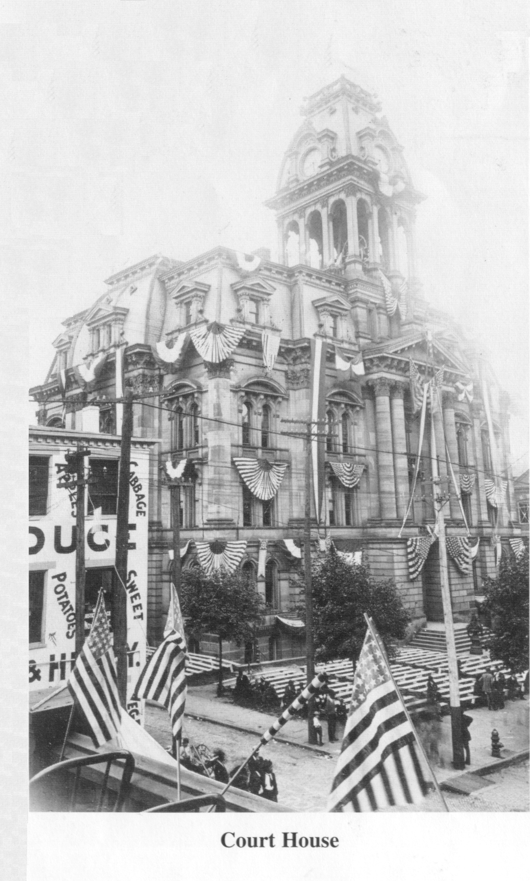
Jefferson County Chapter,
Ohio Genealogical Society

